**BỘ GIÁO DỤC VÀ ĐÀO TẠO**

# **TRƯỜNG ĐẠI HỌC QUỐC GIA THÀNH PHỐ HỒ CHÍ MINH**

**TRƯỜNG ĐẠI HỌC CÔNG NGHỆ THÔNG TIN**

🙞✪🙜



**ĐỒ ÁN MÔN HỌC**

**MÔN HỌC: QUẢN TRỊ MẠNG VÀ HỆ THỐNG**

**TP.HỒ CHÍ MINH – NĂM 2022**

BÁO CÁO CHI TIẾT

**Môn học: QUẢN TRỊ MẠNG VÀ HỆ THỐNG**

**Kỳ báo cáo: Đồ án**

**Tên chủ đề: Zabbix**

*GV: Trần Thị Dung*

*Ngày báo cáo: 24/10/2022*

**Nhóm: Group02**

1. **THÔNG TIN CHUNG:**

* Lớp: **NT132.N11.ATCL**

|  |  |  |  |
| --- | --- | --- | --- |
| **STT** | **Họ và tên** | **MSSV** | **Email** |
| 1 | Hoàng Văn Anh Đức | 20520890 | [20520890@gm.uit.edu.vn](mailto:20520890@gm.uit.edu.vn) |
| 2 | Nguyễn Thái Dương | 20520463 | [20520463@gm.uit.edu.vn](mailto:20520463@gm.uit.edu.vn) |
| 3 | Nguyễn Đình Kha | 20520562 | [20520562@gm.uit.edu.vn](mailto:20520562@gm.uit.edu.vn) |

1. **NỘI DUNG THỰC HIỆN:**

|  |  |  |  |
| --- | --- | --- | --- |
| **STT** | **Công việc** | **Thành viên phụ trách** | **Kết quả tự đánh giá về phần được phân công** |
| 1 | Làm đồ án (zabbix server,monitor website) , làm video demo, viết report | Hoàng Văn Anh Đức | 100% |
| 2 | Làm đồ án (zabbix-agent ubuntu) , làm silde, chỉnh sửa report | Nguyễn Thái Dương | 90% |
| 3 | Làm đồ án (zabbix-agent window) ,chỉnh sửa slide, chỉnh sửa report | Nguyễn Đình Kha | 90% |

**Phần bên dưới của báo cáo này là tài liệu báo cáo chi tiết của nhóm thực hiện.**

Mục lục

TRƯỜNG ĐẠI HỌC QUỐC GIA THÀNH PHỐ HỒ CHÍ MINH 0

I. Introduction 2

1.2. Overview 2

1.1. Definition of zabbix and what does it monitors 2

1.2. Components 3

1.2.1. Zabbix’s Components 3

1.3. Operation 4

II. Implementation and Result 4

2.1. Topology 4

**2.2.** **Installation and Copnfiguration** 5

**2.2.1.** **Set up Server** 5

1.2.2. SET UP AGENT (Linux) AND CONFIGURE 6

1.2.3. MONITOR FROM SERVER (use the web interface) 7

2.2.4. SET UP AGENT (WINDOW) 10

2.2.5 SET UP (WEBSERVER / WEBSITES) FOR MONITORING 12

ADDITIONS : MORE ABOUT ZABBIX 20

III. SELF-ASSESSMENT 20

IV. ANSWER 21

1. Introduction
2. Overview
   1. Definition of zabbix and what does it monitors

* Zabbix is an enterprise-class open-source distributed monitoring solution.
* Zabbix is a software that monitors numerous parameters of a network and the health and integrity of servers, virtual machines, applications, services, databases, websites, the cloud and more.
* Zabbix uses a flexible notification mechanism that allows users to configure e-mail based alerts for virtually any event. This allows a fast reaction to server problems
* Network monitoring
* Network performance
* Network health
* Configuration changes
* Server monitor
* Server performance
* Server availability
* Configuration changering
* Cloud monitoring: Google apps, Amazon WebService, Google clouds, …
* Application monitoring: Gitlab, Microsoft IIS, …
* Service monitoring: Git, Active Directory, Nginx, …

1. Components
   * 1. Zabbix’s Components

* Zabbix consists of several major software components, the responsibilities of which are outlined below:
* **Zabbix Server**
* This is the centre of the Zabbix software.
* The Server can remotely check networked services (such as web servers and mail servers) using simple service checks, but it is also the central component to which the Agents will report availability and integrity information and statistics
* The Server is the central repository in which all configuration, statistical and operational data are stored, and it is the entity in the Zabbix software that will actively alert administrators when problems arise in any of the monitored systems.
* **Zabbix Agent**
* In order to actively monitor local resources and applications (such as harddrives, memory, processor statistics etc.) on networked systems, those systems must run the Zabbix Agent.
* The Agent will gather operational information from the system on which it is running and report these data to the Zabbix for further processing.
* In case of failures (such as a harddisk running full, or a crashed service process), the Zabbix Server can actively alert the administrators of the particular machine that reported the failure.
* The Zabbix Agents are extremely efficient because of use of native system calls for gathering statistical information.
* **The Web Interface**
* In order to allow easy access to the monitoring data and the configuration of Zabbix from anywhere and from any platform, the Web-based Interface is provided.
* The Interface is a part of the Zabbix Server and is usually (but not necessarily) run on the same physical machine as the one running the Zabbix Server.

1. Operation

* Zabbix works via three discovery mode options:
* Network discovery periodically scans an IT environment and records a device's type, IP address, status, uptimes and downtimes…
* Low-level discovery automatically creates items, triggers and graphs based on the discovered device. Low-level discovery can create metrics from Simple Network Management Protocol (SNMP) object identifiers, Windows services, Open Database Connectivity (ODBC) Structured Query Language (SQL) queries, network interfaces and more.
* Auto-discovery automatically starts monitoring any discovered device using a Zabbix agent
* Polling and trapping
* Passive checks (polling):
* Zabbix server requests a value from Zabbix agent.
* Agent processes the request and returns the value to Zabbix server.
* Active checks (trapping):
* Zabbix agent requests from Zabbix server a list of active checks.
* Agent sends the results in periodically.

1. Implementation and Result
   * 1. Topology

1. **Installation and Copnfiguration**
   * 1. **Set up Server**

**a. Install Zabbix repository**

# wget https://repo.zabbix.com/zabbix/6.2/ubuntu/pool/main/z/zabbix-release/zabbix-release_6.2-2%2Bubuntu22.04_all.deb

# dpkg -i zabbix-release_6.2-2+ubuntu22.04_all.deb

# apt update

**b. Install Zabbix server, frontend, agent**

# apt install zabbix-server-mysql zabbix-frontend-php zabbix-apache-conf zabbix-sql-scripts zabbix-agent

Download sql-server: apt install mysql-server

**c. Create initial database**

Make sure the database server up and running.

Run the following on the host database

# mysql -uroot -p

password

mysql> create database zabbix character set utf8mb4 collate utf8mb4_bin;

mysql> create user zabbix@localhost identified by 'password';

mysql> grant all privileges on zabbix.* to zabbix@localhost;

mysql> set global log_bin_trust_function_creators = 1;

mysql> quit;

**On Zabbix server host import initial schema and data. I am prompted to enter my newly created password.**

# zcat /usr/share/zabbix-sql-scripts/mysql/server.sql.gz | mysql --default-character-set=utf8mb4 -uzabbix -p zabbix

**Disable log_bin_trust_function_creators option after importing database schema.**

# mysql -uroot -p password

mysql> set global log_bin_trust_function_creators = 0;

mysql> quit;

**d. Configure the database for Zabbix server**

**Use tool for text editor like vim, nano, … (nano /etc/zabbix/zabbix_server.conf)**

DBPassword=password

**e. Start Zabbix server and agent processes**

**Start Zabbix server and agent processes and make it start at system boot.**

# systemctl restart zabbix-server zabbix-agent apache2

# systemctl enable zabbix-server zabbix-agent apache2

Check server’s status: systemctl status aphache2

* + 1. SET UP AGENT (Linux) AND CONFIGURE

1. **Install Zabbix repository**

# wget <https://repo.zabbix.com/zabbix/6.2/ubuntu/pool/main/z/zabbix-release/zabbix-release_6.2-2%2Bubuntu22.04_all.deb>

# dpkg -i zabbix-release_6.2-2+ubuntu22.04_all.deb

# apt update

1. **Install Zabbix agent**

# apt install zabbix-agent

1. **Config file /etc/zabbix/zabbix_agentd.conf to change hostname of agent and ip which it want to connect**

Nano /etc/zabbix/zabbix_agentd.conf



In my work : ip of Server is 10.0.2.15

And ip of agent is : 10.0.2.4



Listen on this port to accept connection from server





Config Hostname = hostname of agen

To find hostname use command : hostname in the terminal of agent



Check if fire wall is active or not (In this work I enabble it and allow it to accept port 10050/tcp )

*If I pass this step , the agent will run normally in case the firewall is not active

1. **Start Zabbix agent process**

**Start Zabbix agent process and make it start at system boot.**

# systemctl restart zabbix-agent

# systemctl enable zabbix-agent

* + 1. MONITOR FROM SERVER (use the web interface)

To monitor from server , I have to create host by doing the following steps :

1. Go to zabbix server ‘s display
2. Click Configuration -> hosts ->Create host

Fill the form with information of the agent and click add

For example : My added host

Check the connection :

Monitoring ->hosts

* Working fine

Right click on the name of agent and choose the part want to see

I choose “ latest data “ for example

### 2.2.4. SET UP AGENT (WINDOW)

Download window agent :

[Download Zabbix agents](https://www.zabbix.com/download_agents?version=6.2&release=6.2.3&os=Windows&os_version=Any&hardware=amd64&encryption=OpenSSL&packaging=MSI&show_legacy=0)

Install and fill the ip of zabbix server.

Go to server and configure client with Host name and its ip address.

=>Result :

Window agent is monitored.

Some of its graphs ‘s information

### 2.2.5 SET UP (WEBSERVER / WEBSITES) FOR MONITORING

Configuration -> hosts->Create host->Add

Diifer from window and linux monitoring , Hostname of website can be set by my opinion .

Click on “web” button of “Web monitoring” to configure its feature

Next , “Create web senario” in the top right corner

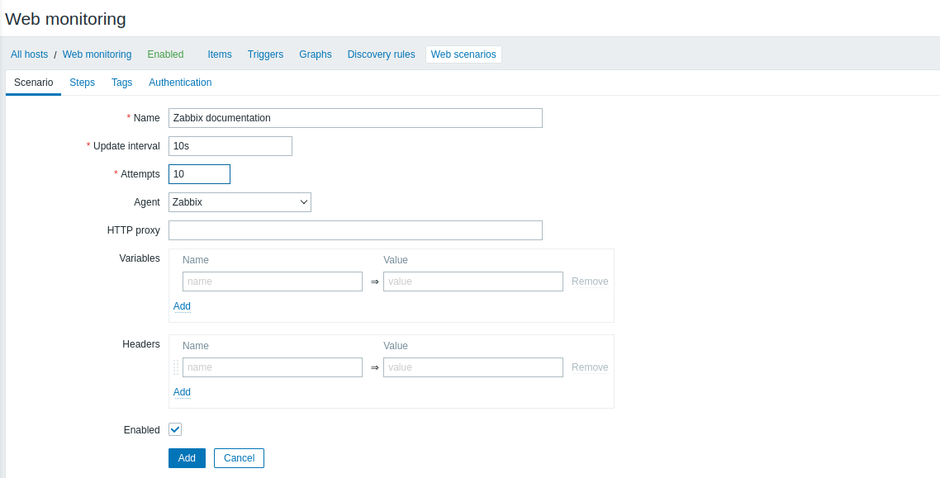

Now , i can see a lot of parameters to fill in.

Name’s field is optional

**Update interval** : how often I want to check my website

**Attemps** : how many times I want to colect data from the web

**Agent**  : kind of browser I want to monitor

**Variables and headers** : the purpose of these set up is to check the page is it up or is running , check the response code

Ex: Some sort of forum , I want to log in , post some sort of comments , verify that this comment is pushlished , …

Move to “step” and click add

**Post type** : post the form data or the raw data

**Post field** : what kind of post fields with the values I want to add variables and headers .This is only used if I want to login , post some content and check its conditions (for the simple monitoring I’ll skip this )

**Follow redirects** : depends on webpage’s configuration . Whether this url is opening the web page right away or there is some sort of redirect

**Retrieve mode** : Full body or just the header of the reponses or both . Also can apply the curl request through CLI when checking some sort of the webpage

**Time out** : what will be the timeout for this check

**Required string** : allow to check some sort of the string in the webpage I try to open . I can check for “whatever string” in the web page

The required status code : this should be http code and if everything is correct

=>The expected code is 200

Click Add.

This demo I’ll check two pages so this is the configuration of the second page :

After added two steps in the scenario .Let’s go to Monitoring->Hosts

In the “Web monitoring” has the “web” with the blue color , click on it and see its status



Click “Zabbix documentaion” to have a closer look



I can see its speed , response time , response code , status and its graphs

These pages don’t support javascripts so as long as I log in form is using javascript most likely I will not able use tips and tricks or whatever else to success-fully log in using the web scenario

There is no IF – ELSE . Ex : I created multiple steps no limitations , if the first step fails then all scenario fails and there is no way I can do the if else scenario

I created a trigger for my monitoration

( **Triggers** are logical **express**ions that "evaluate" **data gathered by items** and **represent the current system state** )

Configuration ->Hosts -> “Web monitoring” -> triggers -> Create triggers

In this trigger , I set up if last value is higher than 5 then it’ll be a high severity problem

->Click add

In the previous data , the first index page’s download speed is much higher than 5 . Now I go to **Monitoring -> Dashboard-> Global view** to see what are showed .

The problems are showed .

P/s : There are more informations than just download speed , … depends on my configuration and what I want to see .

### ADDITIONS : MORE ABOUT ZABBIX

Zabbix is 100% Enterprise-ready

**Unlimited scalability**

- From monitoring smart home to multi-tenant enterprise environments - Zabbix is scalable to any infrastructure.

**Distributed monitoring**

- Deploy and scale a distributed Zabbix infrastructure from a central Web UI with native encryption support between all of the components.

Secured and safe

- Keep sensitive information secure by storing it in an external vault.

**High availability**

- Ensure 24/7 uptime and negate the risk of data loss for Zabbix infrastructure with Zabbix high availability solution.

**Flexible**

- Monitor whatever we want - Zabbix comes with many different ways to collect data, transform it, analyze and visualize it.

1. SELF-ASSESSMENT

|  |  |  |  |  |  |
| --- | --- | --- | --- | --- | --- |
|  | 1 | 2 | 3 | 4 | overal |
| present |  |  | x |  | 3 |
| demo |  |  | x |  | 3 |
| theory |  |  |  | x | 4 |
| report |  |  |  | x | 4 |

1. ANSWER
2. Can zabbix monitor while on MacOS ?

* Chúng ta chưa thể giám sát trên MacOS
* Tham khảo 1 số loại hệ điều hành khác mà chạy được zabbix server
* <https://www.zabbix.com/download>

1. Zabbix hoạt động có yêu cầu giao diện trong giao diện người dùng Zabbix không ?

* Có yêu cầu giao diện người dùng

1. What problems does Zabbix have when using a network larger than 1000+ nodes.

* Trong video demo chỉ có vài client nên cài đặt client trên UI khá dễ dàng nhưng khi có trên 1000 clients thì sẽ không thể sử dụng cách này thay vào đó sẽ dùng phương thức khác (Network discovery hoặc low-level discovery)

**HẾT**